FOR IMMEDIATE RELEASE:
Photo below and upon request.

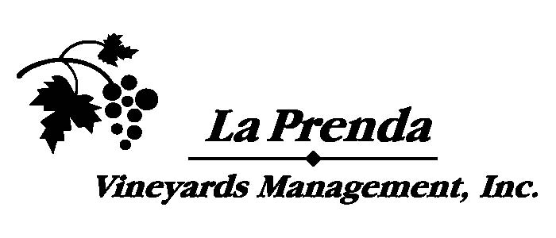

MIKE COX NEW WINEMAKER
FOR LA PRENDA VINEYARDS AND THEIR
SONOMA COLLECTION WINES

Veteran Winemaker Chosen to Direct Unique
Winery Created in Service of Grape Farmers

SONOMA, (January 28, 2020)—Sonoma Collection announces that Mike Cox will take over as winemaker for all their winemaking projects. Cox worked alongside pioneering vintner Walter Schug for the past 25 years where he crafted highly regarded, ageable wines from vineyards in Sonoma Valley, Sonoma Coast and Carneros. A Sonoma native, Cox graduated from UC Davis with a degree in Enology in 1991 while working his way up through local wine cellars during summer months. He joined Schug Winery in 1995, taking over the Winemaker role, while Walter Schug shifted to “Winemaster” as he approached retirement. Cox was in charge of all day to day production, long term planning and both on and offsite winemaking.

Sonoma Collection is the brainchild of Ned Hill who also owns La Prenda Vineyards Management in Sonoma County. Beginning in 2008, La Prenda now farms more than 30 estate properties covering over 900 acres. In 2010 and 2011 an oversupply of uncontracted grapes on the spot market caused some growers to crush their grapes, turn them into wine and then sell it later in bulk. Hill realized he needed to do more for grower clients than just mange their vineyards. He started helping growers sell their grapes to wineries as well as helping them make wine for later sale on the bulk wine market. By 2013 Hill took it a step further, using those same grapes to release his own wines while working with consulting winemaker Alex Beloz.

Hill’s Sonoma Collection was successful, even capturing a top ten spot in Wine Business Monthly’s annual Hot Brands listing. “Sonoma Collection was doing pretty well,” said Hill, “but the time was right to get a full-time winemaker and up our game. Mike and I have worked together for 20 years during our farming of the Schug Estate and I am delighted and excited to have his talents and energy as part of our team. Having him on board will allow us to find the most profitable path for our clients as we enter a challenging grape market and move towards producing more wine for our clients.”

Cox is equally excited at the possibilities offered by Sonoma Collection. “Having worked with Ned for two decades, I jumped at the chance to broaden my palette and work closely with the vineyard sites he farms. I love the idea of bringing these wines to market directly, rather than seeing them get lost in bigger blends. I like that we are a farming business first, and aim to bring well-crafted, honest wines to the table.”

Both Hill and Cox make no apologies for being Sonoma-centric. They share the belief that good Sonoma vineyards can produce wines to rival those anywhere on the planet. Cox sums up his job this way, “Basically, my job is to bring out the individual vineyard character and over-deliver at price point while maintaining style and elegance in the wines.”

Sonoma Collection is a family-owned business featuring sustainably farmed wines honoring Sonoma Valley grape farmers. Other labels include Fifth Hill, La Prenda, Happy Wife, and 95476. La Prenda Vineyards Management has been in business since 2008 and farms over 30 properties in the Sonoma Valley, Carneros, Sonoma Mountain and Bennet Valley appellations that are certified Fish Friendly Farming. They provide quality farming while increasingly incorporating mechanization in a changing farming environment. For more information visit https://www.laprendavineyards.com/.

# # #

Media Contact:
Michael Coats (707) 935-6203 or michael@coatspr.com
Allison Coats (707) 363-6508 or allison@coats.com

